Illustration of Kalman Filter & Complementary Filter

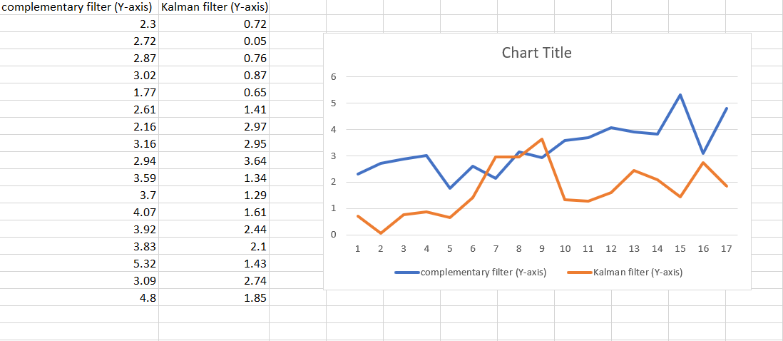

IMU sensor data Configuration